**UNIVERSIDAD TECNOLÓGICA DE CHIHUAHUA**

**ENGINEERING IN DEVELOPMENT AND MANAGEMENT OF SOFTWARE**



GPS Pet Locator Page with GPS Tracking Collars for the enterprise PawSeekers

**INTERNSHIP REPORT TO OBTAIN THE**

**ASSOCIATE DEGREE IN ENGINEERING IN DEVELOPMENT AND MANAGEMENT OF SOFTWARE**

SUBMITTED BY:

* Jaziel Parra Olivas 6520150023
* Derek Ricardo Torres Mendez 6521150007
* José de Jesús Arteaga Ramírez 6521150002

#### Month day number, year. Chihuahua, Chih.

**General observations (DELETE this section once the report is finished, its only purpose is to provide a support guideline):**

* Use passive voice in present tense during the development of this report.

Right examples: “a maintenance plan was established”; “a diagram was designed”; “a strategic business plan was proposed.”

Wrong examples: “I established a maintenance plan”; “I designed a diagram”, “I proposed a strategic business plan.”

* Font type:
  + Times New Roman size 12 for body text.
  + Level 1 heading: size 16 (example: **Chapter I. General Information of the Enterprise**);
  + Level 2 heading: size 14 **(**example: **1.1. Enterprise Description**);
  + Level 3 heading: size 12 (example ***4.1.1. Quantitative Results***);
  + Level 4 heading, this type does not have to be numbered: size 12, bold italic (***History***).

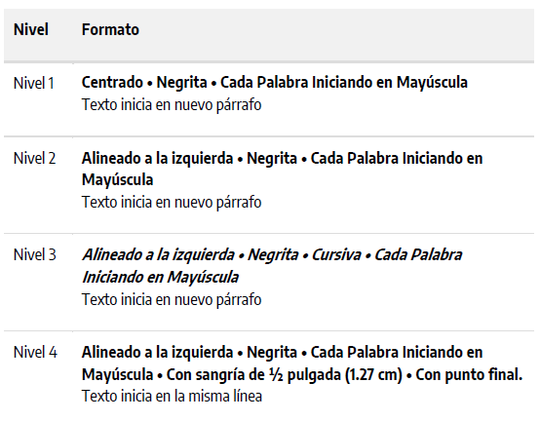

* Margins: top 2.5 cm, bottom 2.5 cm, left 3.0 cm, right 2.5 cm.
* Line spacing:
  + Double spaced, in abstract, index, and references.
  + 1.5 The rest of the document.

* Indentation:
  + The first line of each paragraph must have a ½-inch indentation (1.27 cm) on the left margin, you can use TAB key.
  + The first line of the first paragraph of the abstract should not be indented.
  + Hanging indentation must be used only for References section.

Example of hanging indentation:

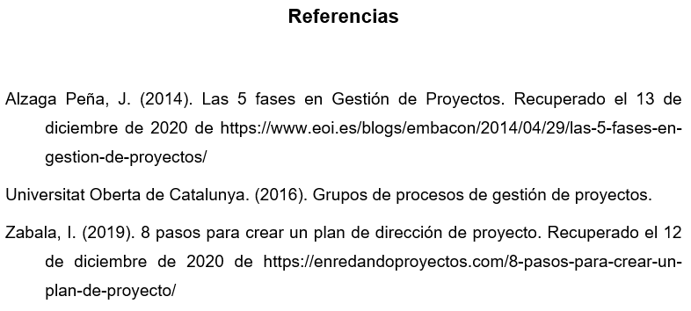

* Paragraphs must have justified alignment (justified alignment means that space is added between words do that both edges of each line are aligned with both margins).
* You must not add any additional spaces between paragraphs (ENTER); besides, you must not insert any line breaks between paragraphs, headings or subheadings.
* Headings and subheadings are not indented.
* Page numbering:
  + You must use page numbering Word function to insert page numbers.
  + Numbers must be on the right upper corner of the page.
  + Every single page must be numbered, and the cover page must be numbered as page 1, but it must not be included in the Index.
* Pictures, logotypes, blueprints, cartographic maps, screenshots, diagrams, graphic organizers, graphs and organizational charts are considered figures.
* Elements formed by columns and rows where numbers, text or a combination of both are presented are considered tables. Examples: matrixes, SWOT, lists or chronograms.
* Parts of a table:
  + Table number: the number of the table is the first element (i.e., Table 1). Use bold font. Number tables in the order that they are mentioned in your report.
  + Heading: You must write the heading of the table in a double spaced line under the number of the table. Use a brief but descriptive heading. Use italics.
* Matrixes (e.g. SWOT), lists, and chronograms are considered tables.
* Page numbering:
  + Headings: Tables can include a variety of headings according to the data being presented. All of the tables must include column headings. It is suggested to center the text of the headings of each column.
  + Body: the body of the table includes all of the rows and columns of a table (including the row of headings). The body of the table can be single spaced. It is recommended to center the text of all of the table cells, but, if left alignment allows a better visibility of the information, consider to do it as the best option.
  + Note: Use notes to describe the contents of the table that cannot be understood by the heading of by the data itself. If you use abbreviations in the table, you can describe them in the notes. You can also use the notes to provide copyright of the data; an asterisk must signal any extra information. This is not a mandatory section, therefore use notes only if necessary.

Example:

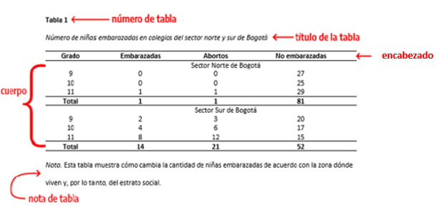

* Tables and figures have the same general format.
* Present tables and figures immediately after have been mentioned in the body to ease the readers’ comprehension of the document. Complementary tables and figures which are not absolutely necessary for reading comprehension must be added in the Appendix section.
* Number each one of the tables and figures in the order that they are presented. Font format is bold, Times New Roman, size 12, left alignment, and the heading of the table in italics.

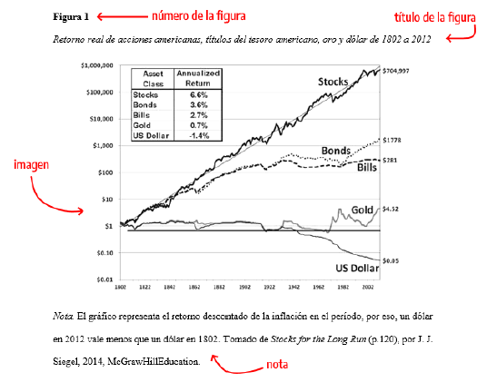

* Take the following into consideration regarding tables and figures:
  + Tables and figures complement information, do not duplicate the same text.
  + Inside the text, they are cited by the number of table or figure.
  + Use the specific number of the table or figure. Example: “… as it is shown in Table 2”.
  + Do not write “the table shown above” or “the table in page 14”.
  + The headings of tables and figures must be short, but clear, explanatory, and descriptive.
* To provide the Copyrights of a table: if the table includes a footnote, it is written after it, if the table is taken from other source, it must be added in in the footnote of the table. Example:

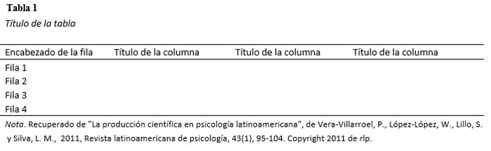

* To provide the Copyrights of a figure: if the figure is taken from other source, it must be added in in the footnote of the figure. See the example above.
* Lastly, in both, tables and figures it must be included a full reference at the end of the document in the References section according to the APA Format 7th edition.
* Regarding the table and its contents: It must be formed exclusively by three horizontal lines, the one that separates the heading from the data, a top and a bottom one. Each column must have at the top a heading to describe the data being presented (see the example of the table above).
* Avoid frames in tables and figures.
* Do not upper case only. Follow orthographic rules.
* Use uppercase letters only when necessary.
* Avoid vague language such as: among others, some authors, etc. Avoid vague qualifying adjectives; some examples of this situation can be “the quality is *bad*”; “the organization of the enterprise is *good*.”
* Make appropriate grammatical corrections in structure, agreement, and usage of parts of speech.
* Check spelling and punctuation.
* Use dictionaries frequently to dispel any doubts or to find accurate expressions.
* Avoid overgeneralization terms such as: never, always, all…
* Check clarity, coherence, cohesion, and style on the document.
* Start each chapter of this document in a new page.
* Delete all of the presented charts in this document before final submission.
* Once the document is finished, update the index.

Part of this reference document was written based on:

Guía Normas APA 7ª edición

<https://normas-apa.org/wp-content/uploads/Guia-Normas-APA-7ma-edicion.pdf>

***Basic guidelines on the length of each section of the Internship Project.***

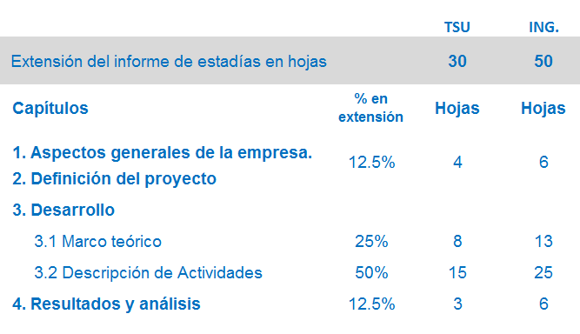

## ****Acknowledgements****

#### This section is optional and it is written in first person. Avoid the usage of repetition. There is no specific format to be used, feel free to use the format that you consider to be adequate.

Examples:

I would like to express my sincere gratitude to my advisor, Prof. X, for the continuous support…

My completion of this project could not have been accomplished without the support of…

To my caring, loving, and supportive parents, X and Y. Your encouragement when the times got rough are much appreciated…

To my dear husband, X, for his company and love...

Note: If there are not any acknowledgements, delete this section completely and update the index.

**ABSTRACT**

The problem at hand is to find lost pets and reunite them with their owners in an efficient and effective manner. Losing a pet can be distressing for both the owner and the animal, and current methods for locating lost pets often rely social media publications and word-of-mouth to the people nearby, which can be slow and unreliable. To address this issue, a multi-faceted methodology that leverages technology and community engagement was proposed.

The team will develop a centralized online platform where pet owners can report lost pets and provide relevant information such as a description, last seen location, and contact details. This platform will serve as a hub for the lost pet network. As was instructed, the integration of a mobile application its hardly focused to develop to work with the web site. The mobile app has functions that enables users to receive real-time notifications about missing pets in their vicinity, increasing the chances of timely sightings.

While our methodology has shown promising results, there are some limitations to consider. The main issue, the success of the platform relies heavily on user participation, and there is a need for continuous community engagement to ensure its effectiveness. Another problem redeems on the effectivity, since may be instances where pets are unable to be located due to various factors such as limited sightings or insufficient information provided by the owners. Furthermore, the platform's effectiveness may vary depending on the geographical location and the availability of internet connectivity in certain areas.

## Resúmen

El problema que se plantea es encontrar mascotas perdidas y reunirlas con sus dueños de manera eficiente y eficaz. Perder una mascota puede ser angustioso tanto para el dueño como para el animal, y los métodos actuales de localización de mascotas perdidas suelen depender de las publicaciones en las redes sociales y del boca a boca a las personas cercanas, lo que puede resultar lento y poco fiable. Para resolver este problema se propuso una metodología polifacética que aprovecha la tecnología y la participación de la comunidad.

El equipo desarrollará una plataforma en línea centralizada en la que los dueños de mascotas puedan denunciar su pérdida y facilitar información pertinente como una descripción, el último lugar en el que se les vio y datos de contacto. Esta plataforma servirá de centro neurálgico de la red de mascotas perdidas. Como se indicó, la integración de una aplicación móvil su apenas enfocada a desarrollar para que funcione con el sitio web. La aplicación móvil tiene funciones que permiten a los usuarios recibir notificaciones en tiempo real sobre mascotas perdidas en sus proximidades, lo que aumenta las posibilidades de avistamientos a tiempo.

Aunque nuestra metodología ha dado resultados prometedores, hay que tener en cuenta algunas limitaciones. La principal es que el éxito de la plataforma depende en gran medida de la participación de los usuarios, por lo que es necesario un compromiso continuo de la comunidad para garantizar su eficacia. Otro problema redunda en la eficacia, ya que puede haber casos en los que no se localice a las mascotas debido a diversos factores, como avistamientos limitados o información insuficiente facilitada por los propietarios. Además, la eficacia de la plataforma puede variar en función de la ubicación geográfica y de la disponibilidad de conectividad a internet en determinadas zonas.

## 

#### **Index**

Acknowledgements 8

Abstract 9

Resúmen 9

Introduction 13

Chapter 1. General Information of the Enterprise 15

1.1. Enterprise Description 15

1.2. Normative Planning 15

16

16

Chapter 2. Project Definition Statement 17

2.1. Project Background Information 17

2.2. Current Situation Analysis 18

2.3. Problem Statement 18

**2.3.1. Problem Statement Definition** 18

**2.3.2. Objectives** 19

**2.3.3 Project and Research Justification** 21

2.4. Methodology 21

2.5. Chronogram 22

Chapter 3. Project Development 23

3.1. Theoretical Framework 23

**3.1.1. Subsection** 24

3.2. Activities Description 24

**3.2.1. Subsection** 24

**3.2.2. Subsection** 24

Chapter 4. Results and Analysis 25

4.1. Results 25

**4.1.1. Quantitative Results** 25

**4.1.2. Qualitative Results** 25

4.2. Discussion and Conclusions 26

4.3. Recommendations 26

References 27

Appendix 28

Glossary 29

**Tables Index**

Example:

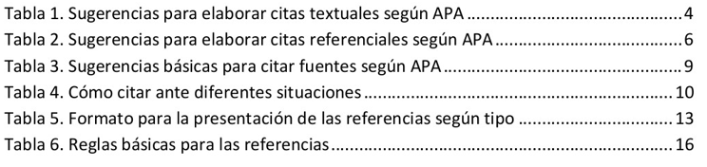

**Figures Index**

Example:

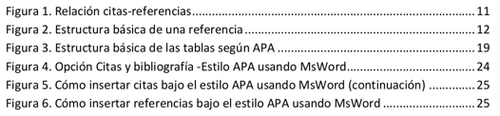

## Introduction

In this section, write the location and a general presentation about the place in which this project was developed. The Introduction must contain the following information:

a) A succinct description of the associate or bachelor profile.

b) An explanation of why the development of this project can be deemed as pertinent.

c) What contribution to the professional formation does this internship provide to the student? What relevance does this internship have in wrapping up the associate’s or bachelor’s degree program?

d) A brief description of the contents of each section of this document.

**Note**: The maximum length of this section is of 2 pages.

This project is focused on helping owners of lost pets to safely recover their animal family member. In the same way, the process of creating this project fosters the growth of the group as multiplatform software developers, using programs such as android studio, or gaining experience in the use of a gps module to the project.

**Chapter 1. General Information of the Enterprise**

## 1.1. Enterprise Description

In this section, describe the enterprise: its name, core business (what does it do?), size (micro, small, medium, and large), location, and any relevant information that could be helpful for the reader to get a general preview of how this enterprise is.

In addition, this section should include the department of the enterprise were the internship took place, as well as the name and position of the mentor or supervisor assigned by the enterprise.

**Note**: The maximum length of this section is of 2 pages.

Many pets, being mostly dogs and cats tend to get lost if they are not given the necessary attention, conventional search options such as talking about it to your neighbors and acquaintances, wanted posters and posting on WhatsApp stories tend not to be as effective and in many cases, the dog is found by the pound or in a very long period of time which affects both the owner and the pet. For this it has been decided to create an application / website with which to share stories in an active community of Seekers and Adopters.

The problem at hand is finding lost pets and reuniting them with their owners in an efficient, fast and effective manner. Very often, when a person loses a pet he panics, if he saw the pet out he will tend to go looking for it, but if he does not find it he will choose to inform the surroundings, this is very important, since the location of lost pets depends on how many people are informed of its disappearance and are willing to help the owner in the search for the animal. Although often successful in the first few hours of disappearance, this method becomes inefficient, as the people contacted do not leave certain areas or are too far away from the search area.

The solution proposed is PetHunter, a multiplatform application with which you can make detailed notices of disappearance of the pet, this includes the pet's name, breed, characteristics, unique features, the area in which it was lost, the urgency, a photo of the dog and other determining factors in identifying your pet. For this purpose, there will be other types of users in the application, which will be in charge of searching for the animals by means of the information provided by others or that they themselves collect, creating a community of relationship between owners and searchers.

This, the application has a third type of user for specific cases when an animal is found but is not the pet, the adopter can search for pets rescued by the searchers that were not the pet of the report requesting, providing them with a home. In this way, it is hoped that this community will evolve and develop its own means of finding different types of lost pets and adopting pets that do not have homes.

## Normative Planning

This section must include the mission and vision statements, values, policies, and organizational chart **only** if the Enterprise has them. In case the document that contains the policies of the enterprise is too long, transcribe only the most relevant points; take into consideration that their maximum length is of a single page. If the Enterprise does not have any of the points mentioned above, mention this situation in the section of Recommendations as a suggestion.

Although the intern **must not** be labeled in the organizational chart, the department where the internship took place has to be highlighted in a different color. Label the organizational chart with the main positions **without** writing the names of the people who hold them.

**Note**: The maximum length of this section is of 6 pages.

#### **Mission**

#### **Vision**

#### **Policies**

#### **Organizational Chart**

#### General Manager

#### Cashiers

#### Warehouse Personnel

#### Sales Personnel

#### Supervisor Assistant

#### Auxiliary

#### Warehouse Chief

#### Floor Chief

#### Supervisor

#### Administrative Area

#### Assistant Manager

#### Production Area

## 

#### Cash Department

#### Accountantt

#### Inventory Inventarios

***Figure 1. Organizational Chart of (Name of the Enterprise)***

**Chapter 2. Project Definition Statement**

## 2.1. Project Background Information

In this section, clearly describe what problem the enterprise faces that can be addressed through this project (the solution(s) of this problem are not mentioned in this section).

In other words, in this section explain how the processes related to the problem are performed before starting the project.

Note: The maximum length of this section is of a single page.

## 

## 2.2. Current Situation Analysis

This sections starts with a general collection of ideas and opinions of the people involved in the processes. Then, observe how are the activities in the process performed to identify the problem. Some collection methods can be interviews, questionnaires, and observations (keep all the collection instruments to add them in the appendix).

Once the process of collection is finished, make an analysis of the data through the following tools: brain storming, SWOT analysis, Ishikawa diagram, Pareto chart, or any other analysis methodology.

Based on the outcome of the data analysis, make a diagnostic of the causes of the problem including the following information: area, personnel, process, and how the problem has a quantitative or qualitative impact on the process, area or enterprise.

Note: The maximum length of this section is of 2 pages and each element must be written in a separate paragraph.

## 2.3. Problem Statement

### **2.3.1. Problem Statement Definition**

Base on the outcomes of the previous analysis, state the problem by writing declarative sentences.

Examples:

* The lack of a sales plan in the spare parts area makes the enterprise uncompetitive because other enterprises in the market have a larger quantity of customers.
* The variation if the manufacturing process affect the product quality.
* The lack of an organized file system affects the customers’ waiting time.
* The procedures and techniques of quality control are currently limited to examine the process according to the criteria of each supervisor and not to process control or to the product.

### **2.3.2. Objectives**

The statement of the objectives explicitly expresses the aim of the project and what goals must be achieved to consider that the problem stated has been solved. The **general objective** must be written in a single paragraph, and it must answer the following questions:

What?: The paragraph begins with an infinitive verb which is the action to solve the problem of the enterprise.

How?: Then, state the technology or process to solve the problem.

Where?: Include the area and sections where the project takes place.

When?: Define the amount of time that the project will take to be implemented.

Examples of objectives:

To increase the competitiveness of the enterprise developing a sales plan for the spare parts are of the enterprise Z, from May to August 2016.

To increase the quality of X product by applying a _________________ process in the manufacturing area of the enterprise Z, from May to August 2016.

To contribute to the improvement of customer service through the development of a data base in the sewing area do the enterprise Z, from May to August 2016.

To standardize que quality control through ________________ to examine the final product of the ________ area of the enterprise Z, from May to August 2016.

The **specific objectives** of the project must derive from the general objective. These objectives are used to evaluate the outcomes of the project and to know if the problem was solved. Specific objective must be specific, observable, measurable, attainable, evaluative, and relevant.

Examples of infinitive verbs: to install, to document, to improve, to implement, to increase, to develop, to design, to plan, to streamline, to standardize, to reduce, etc.

Examples of specific objectives:

* To reduce the customers’ waiting time a 10%.
* To improve the documents organization.
* To evenly distribute workload among the administrative personnel.

## 

### **2.3.3 Project and Research Justification**

In this section, present the reasons why the topic and the problem of the project were selected, taking into consideration the significance, vulnerability, extent, and feasibility of the project and the benefit that the enterprise obtains out of it.

## 2.4. Methodology

In this section write the sequence of actions to do in order to solve the problem that has been stated. The actions must be written in logical and chronological order.

Each one of the actions must describe what is going to be done and what resources are necessary to achieve their performance.

Example:

#### To collect information

#### To analyze the information and to define improvement opportunities to solve the problem

#### To design the solution

#### To develop the solution

#### To apply

#### To validate

#### To evaluate the results according to the objective

**Note**: Each one of the sections of the Methodology must match with the Chronogram and the Activities Description.

The information presented in this guideline is only an example of the steps that could be stated in the Methodology, take into consideration that the steps have to align with the project and the competencies of the profile of each major. Consult the UTCH advisor to design the process.

## 

## 2.5. Chronogram

Define start and completion dates for each section of the Project, as well as the internship report in this section.

This chronogram is the same that is included in the *Autorización del Plan de Trabajo de Estadía* (F-SA-35) format.

The activities included in the chronogram must match those included in the Methodology section.

|  |  |  |  |  |  |  |  |  |  |  |  |  |  |  |  |  |  |
| --- | --- | --- | --- | --- | --- | --- | --- | --- | --- | --- | --- | --- | --- | --- | --- | --- | --- |
| (**Name of the project**) | | | | | | | | | | | | | | | | | |
| (in name of the enterprise) | | | | | | | | | | | | | | | | | |
| (From January 23rd to April 27th 2021) | | | | | | | | | | | | | | | | | |
| N° | Activities |  | 1 | 2 | 3 | 4 | 5 | 6 | 7 | 8 | 9 | 10 | 11 | 12 | 13 | 14 | 15 |
|  |  | P |  |  |  |  |  |  |  |  |  |  |  |  |  |  |  |
| D |  |  |  |  |  |  |  |  |  |  |  |  |  |  |  |
|  |  | P |  |  |  |  |  |  |  |  |  |  |  |  |  |  |  |
| D |  |  |  |  |  |  |  |  |  |  |  |  |  |  |  |
|  |  | P |  |  |  |  |  |  |  |  |  |  |  |  |  |  |  |
| D |  |  |  |  |  |  |  |  |  |  |  |  |  |  |  |
|  |  | P |  |  |  |  |  |  |  |  |  |  |  |  |  |  |  |
| D |  |  |  |  |  |  |  |  |  |  |  |  |  |  |  |
|  |  | P |  |  |  |  |  |  |  |  |  |  |  |  |  |  |  |
| D |  |  |  |  |  |  |  |  |  |  |  |  |  |  |  |

# Chapter 3. Project Development

## 3.1. Theoretical Framework

The Theoretical Framework consists on the available knowledge on the subject that is being developed, this section must be short and concise. Take into consideration that a Theoretical Framework consists of concepts, definitions and reference to relevant scholarly literature that is used for your project. Demonstrate in this section understanding on the topic. This section must not plagiarize any author.

In other words, this section is the theoretical explanation of the elements that were used to solve the problem and support the project.

Quotes from authors, both direct and indirect, must be cited in APA format.

*Example:*

The model in education of the Technological Universities seek the innovation through technological-humanistic formation, research generation and technological developments. The educational level that this modality offers, corresponds to 5B2 of the Consejo Internacional de Normalización Educativa (CINE) which outstands because of its mainly practical approach (Romero, 2009). (Indirect quoting)

As mentioned by Monge y Méndez (2007), laboratoriosthose physical spaces appointed to develop practice and to make experimentation. These spaces have presented a series of limitations which unable them to present the desired characteristics. (Indirect quoting)

All careers must be directed by specific principles, rules, and values. According to Perrenoud (2004:10): “La actividad de un profesional, entendido como tal, está gobernada básicamente por unos objetivos y una ética”. (Direct quoting)

## 

### **3.1.1. Subsection**

Substitute the word “Subsection” to the subheading that best fits to a subsequent subsection. Use as many subheadings as necessary and continue with the numbering. In case there are no subsections, this section must be deleted and the index updated.

## 3.2. Activities Description

In this section, describe in detail each one of the steps followed through the development of the project according to the methodology stated in the last chapter. Support the explanation of the description through charts, images, pictures, logotypes, blueprints, cartographic maps, screenshots, diagrams, graphic organizers, application formats, graphs, and organizational charts, or any other resources that serve as evidence of the performed work. All of these sources must follow the format established for tables, figures and appendixes.

**Note**: This section must follow the order of both the methodology and chronogram of activities.

### **3.2.1. Subsection**

Substitute the word “Subsection” to the subheading that best fits to a subsequent subsection. Use as many subheadings as necessary and continue with the numbering. In case there are no subsections, this section must be deleted and the index updated.

### **3.2.2. Subsection**

Substitute the word “Subsection” to the subheading that best fits to a subsequent subsection. Use as many subheadings as necessary and continue with the numbering. In case there are no subsections, this section must be deleted and the index updated.

# Chapter 4. Results and Analysis

## 4.1. Results

In this section, describe in full detail final service and/or product. This is the most relevant section of the document because it is considered the evidence of the Project. Write the analysis of the results in accordance to the objectives stated in Chapter 2, as well as with the internship’s objective.

**Note**: The number of pages in this sections varies according to the level of the description of the final project.

### **4.1.1. Quantitative Results**

Present the obtained measurable data relevant to the objectives of the project in this section. Data can be presented as numeric indicators. Some examples are: percentages, time measurements, length, weight, capacity, money, etc.

Information presented in this section must be backed up with figures or tables which support it, following the format guidelines for tables, figures and appendixes.

### **4.1.2. Qualitative Results**

In this section, present the data collected after the application of the project regarding the specific objectives related to the opinion and perception of the people once the solution to the problem of this project is applied.

This data in collected through observation (observation guidelines), surveys, interviews, or questionnaires (remember to add the instrument in the appendix).

The qualitative results can be backed up with figures or tables to complement the information following the format of figures, tables, and appendixes.

## 4.2. Discussion and Conclusions

Start this section with the objectives stated for this project by answering the problem statement. Take into consideration that the discussion must be based on the results outcomes.

Additionally, mention the experience and benefits in your professional development acquired during the internship and development of the project.

## 4.3. Recommendations

#### Include those follow-up recommendations which could be useful for future generations working on the same project, to keep the project updated, or to suggest improvements from the findings in the results of the project in this section. Also, include possible missing points that might have been identified in the enterprise.

**References**

#### Register all sources of information used to make in-text citations or in the development in the document (books, magazines, PDF documents, webpages, forums, etcetera) in alphabetical order using hanging indentation in this section.

APA 7 (American Psychological Association) format is mandatory. In order to apply this format, use the Word tab “References” to follow instructions or use the online APA 7.0 guideline online. <https://normas-apa.org/wp-content/uploads/Guia-Normas-APA-7ma-edicion.pdf>

#### Examples:

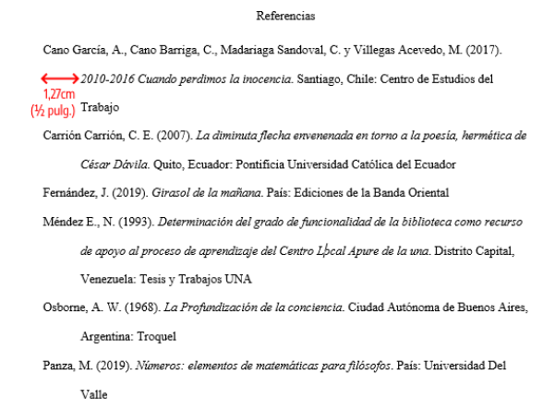

Note: All references must have hanging indentation starting on the second line and must be ordered alphabetically. All of the references made on the body of the document must have their referent in this section.

**Appendix**

#### Add complementary tables and figures, which are not necessary for reading comprehension in the body of the document in this section. Follow the format guideline for tables in figures.

#### Mention tables and figures in de body of the document where it is necessary to make reference to them. Example:

#### **Appendix 1. Interview to general manager format.**

# Glossary

Include the definition of the technical terms used in the body of the document in this section.

These terms must be written in alphabetical order in a list format.

Definitions must be succinct (short and specific, but clear).

Examples:

**Brief.** Guide with relevant information about an Enterprise/client to make a marketing strategy.

**Survey.** Research tool that consists in a series of questions with the purpose of obtaining information from surveyed people.